**Use Wireshark to capture and analyze DNS, TCP, UDP traffic and packet header, packet flow, options and flags.**

**DNS:**

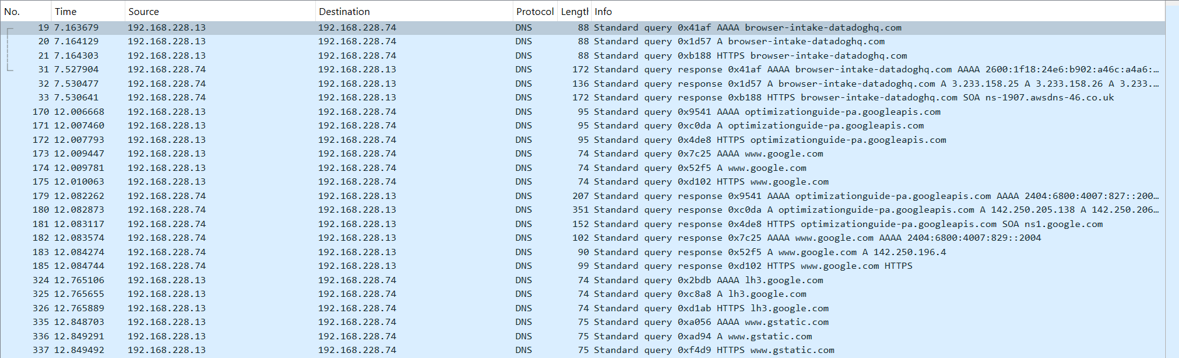

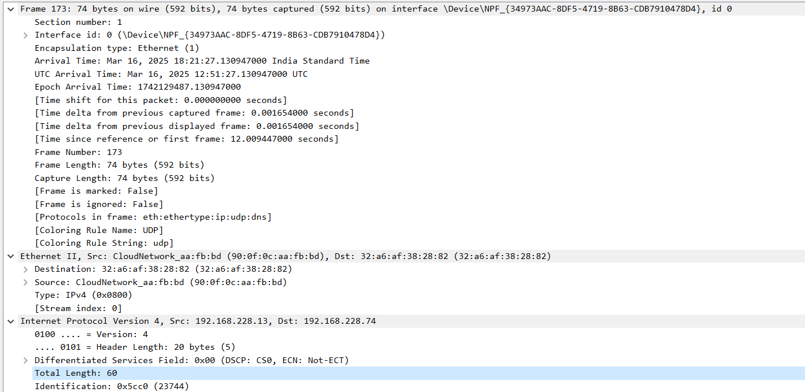

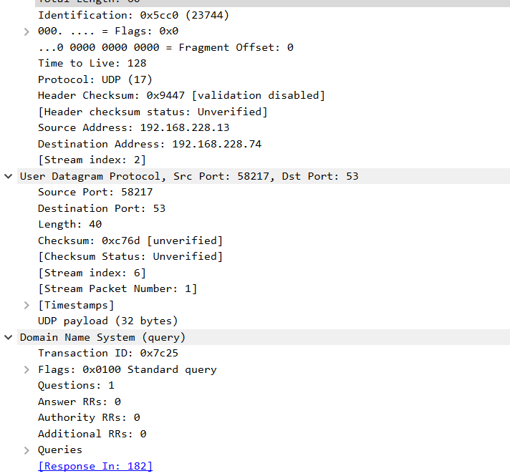

Frame Details:

1. Frame Number: 173 (Captured as the 173rd packet).
2. Frame Length: 74 bytes (592 bits).
3. Protocols in Frame: Ethernet → IP → UDP → DNS.

Ethernet (Layer 2 - Data Link Layer):

1. Source MAC Address: 90:6f:0c:aa:fb:bd (CloudNetwork device).
2. Destination MAC Address: 32:a6:af:38:28:82.

IP Header (Layer 3 - Network Layer):

1. Source IP: 192.168.228.13 (Sender of the DNS request).
2. Destination IP: 192.168.228.74 (Likely the DNS server).
3. IP Version: IPv4.
4. Header Length: 20 bytes.
5. Total Length: 60 bytes.
6. Identification: 0x5cc0 (Unique packet identifier).
7. Differentiated Services Field (DSCP & ECN): 0x00 (Standard traffic).

**TCP:**

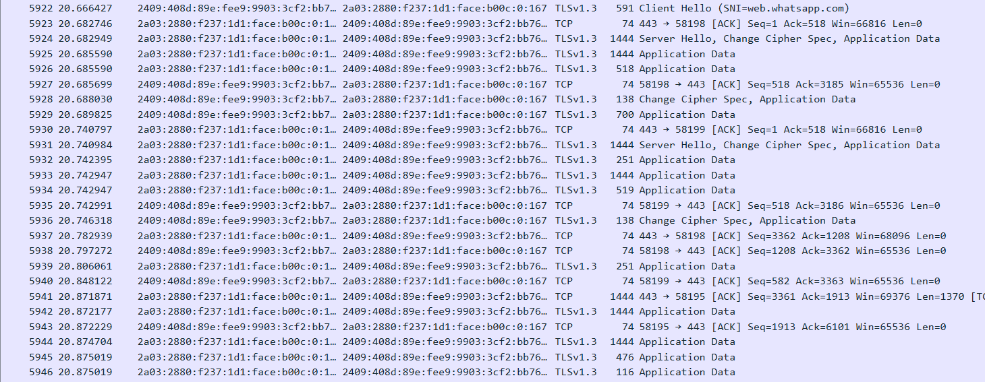

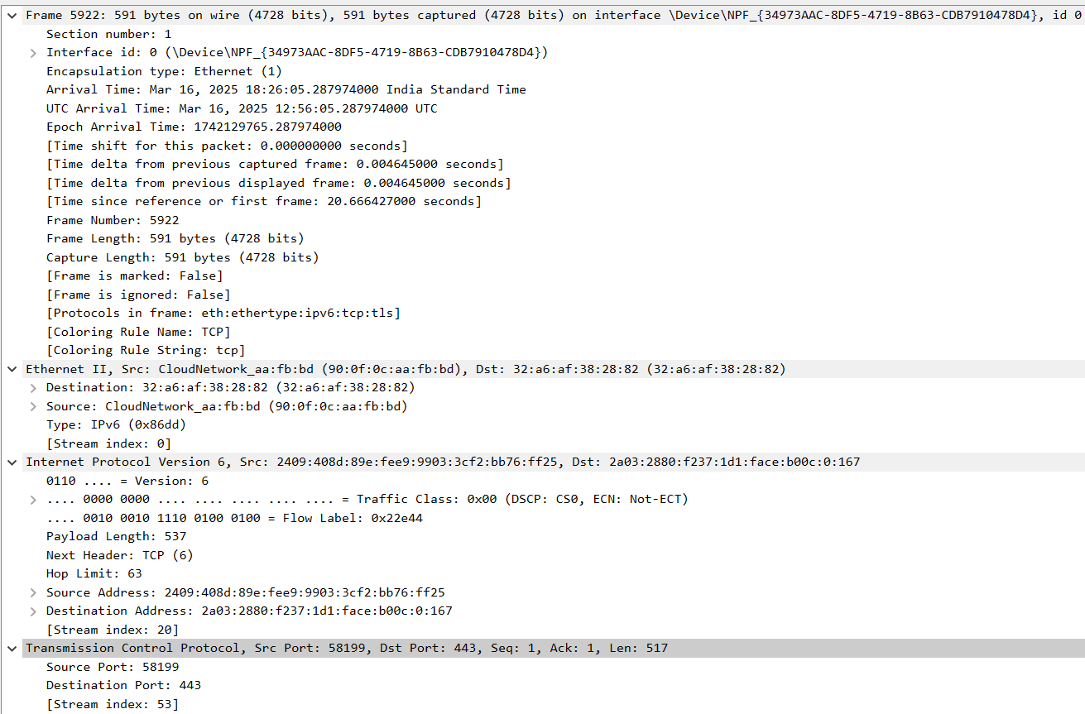

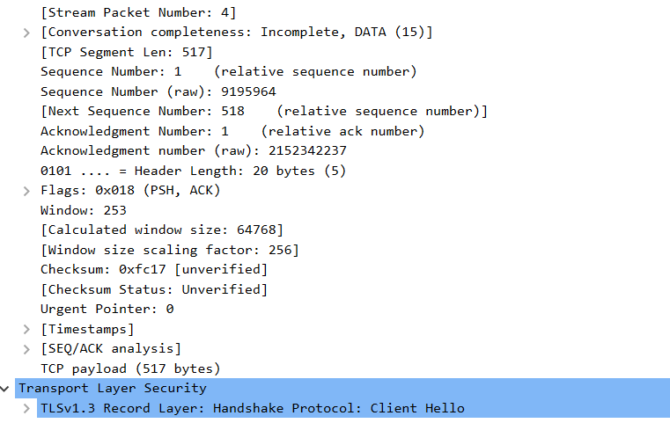

Frame Details

1. Frame Number: 5922.
2. Frame Length: 591 bytes.
3. Protocols in Frame: Ethernet → IPv6 → TCP → TLS.

Ethernet (Layer 2 - Data Link Layer)

1. Source MAC Address: 90:6f:0c:aa:fb:bd (CloudNetwork device).
2. Destination MAC Address: 32:a6:af:38:28:82.

IP Header (Layer 3 - Network Layer)

1. IP Version: IPv6.
2. Source IP: 2409:408d:89e:fee9:9903:3cf2:b76f:ff25.
3. Destination IP: 2a03:2880:f237:1d1:face:b00c:0:167.
4. Traffic Class: 0x00 (Normal priority).
5. Flow Label: 0x22e44.
6. Payload Length: 537 bytes.
7. Next Header: TCP.
8. Hop Limit: 63.

TCP Header (Layer 4 - Transport Layer)

1. Source Port: 58199 (Ephemeral port).
2. Destination Port: 443 (HTTPS).
3. Sequence Number: 1.
4. Acknowledgment Number: 1.
5. Header Length: 20 bytes.
6. Flags:
   * PSH (Push): Data should be immediately pushed to the application.
   * ACK (Acknowledgment): Confirms receipt of previous packet.
7. Window Size: 253 (scaled to 64768).
8. TCP Payload Length: 517 bytes.

**UDP:**



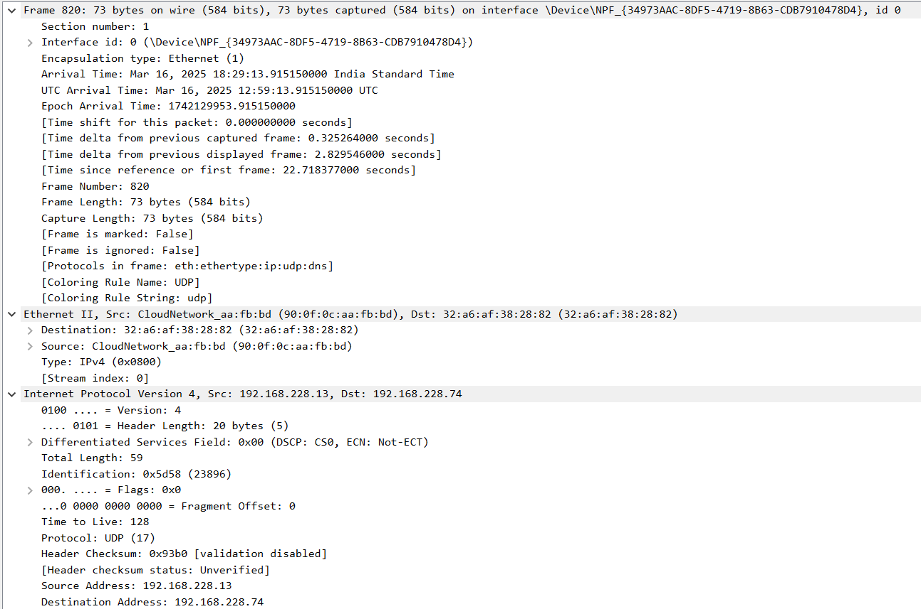

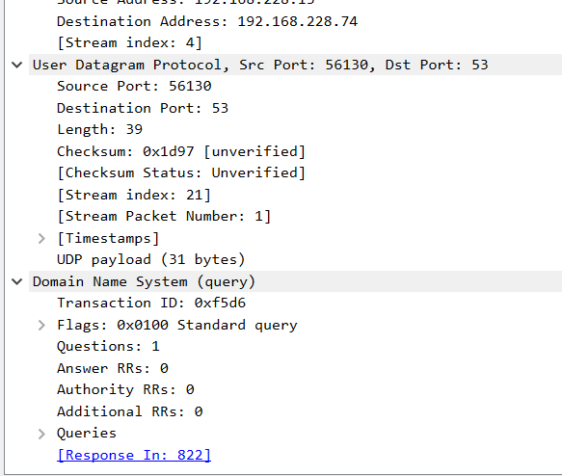

Frame Details:

* The packet is 73 bytes in size.
* It was captured over an Ethernet network using IPv4.
* The source MAC address is 90:0f:0c:aa:fb:bd, and the destination MAC address is 32:a6:af:38:28:82.

IPv4 Layer:

* Source IP: 192.168.228.13
* Destination IP: 192.168.228.74
* Protocol: UDP (17)

UDP Layer:

* Source Port: 56130
* Destination Port: 53 (DNS)
* Length: 39 bytes

DNS Query:

* Transaction ID: 0xf5d6
* Flags: 0x0100 (Standard query)
* Number of Questions: 1
* No Answers, Authority, or Additional RRs